# EDU-LEARN

## A PROJECT ON

**EDU-LEARN**



**UNIVERSITY OF MUMBAI**

*Submitted in partial fulfillment of the requirements of the degree of*

#### BACHELOR’S DEGREE (B.E) IN COMPUTER ENGINEERING,

Submitted by

#### SHRUTI VICHARE - 60 KIRTI KULKARNI - 21 SHREYA KETKAR - 18

**GUIDE: PROF. RAGINI MISHRA**



Department of Computer Engineering

**Vishwaniketan’s Institute of Management Entrepreneurship and Engineering Technology, Khalapur**

ACADEMIC YEAR 2021-2022

**Vishwaniketan’s Institute of Management Entrepreneurship and Engineering Technology**

**Internal Approval Sheet CERTIFICATE**

This is to certify that the project entitled **“EDU-LEARN”** is a bonafide work of

**SHRUTI VICHARE KIRTI KULKARNI SHREYA KETKAR**

Submitted to the University of Mumbai in partial fulfillment of the requirement for the award of the degree of **“BACHELOR’S DEGREE”** in **“COMPUTER ENGINEERING”**.

**PROF. RAGINI MISHRA PROF. ABHIJIT PATIL**

**Project Guide Project Coordinator**

**PROF. PRAVEEN BARAPATRE DR. B.R PATIL**

**HOD (Computer) PRINCIPAL**

**Vishwaniketan’s Institute of Management Entrepreneurship and**

**Engineering Technology**

**Project Report Approval Sheet**

This project entitled **“Edu-Learn”** by SHRUTI VICHARE

KIRTI KULKARNI SHREYA KETKAR

Is approved for the degree of **Bachelors Engineering** in **Computer Engineering.**

**Examiners:**

1. _____________________

2. _____________________

**Date: Place:**

**DECLARATION**

We, declare that this written submission represents our ideas in our own words and where others' ideas or words have been included, I have adequately cited and referenced the original sources. We also declare that we have adhered to all principles of academic honesty and integrity and have not misrepresented or fabricated or falsified any idea/data/fact/source in our submission. We understand that any violation of the above will be cause for disciplinary action by the Institute and can also evoke penal action from the sources which have thus not been properly cited or from whom proper permission has not been taken when needed.

SHRUTI VICHARE

KIRTI KULKARNI

SHREYA KETKAR

**Date: Place:**

**ACKNOWLEDGEMENTS**

It is great sense of accomplishment to express our sincere gratitude to our respected **Guide Prof. Ragini Mishra** for their constant interest, encouragement and valuable guidance during completion of project.

We would like to extend our gratitude to **Prof. Praveen Barapatre** Head Department of Computer Engineering and **Hon. Dr. B.R. Patil** Principal who gave us valuable suggestions and all the required facilities in the college premises to perform our project.

Finally, we express our sincere thanks to all non-Teaching staff in the Department of Computer Engineering, Vishwaniketan’s Institute of Management Entrepreneurship and Engineering Technology, Khalapur who offered valuable time and assistance directly or indirectly to us in completion of our Project.

SHRUTI VICHARE KIRTI KULKARNI SHREYA KETKAR

**ABSTRACT**

E-learning is an integral part of smart education. There are many e-learning systems that are widely available to educational institutions. The challenge is to easily integrate the e-learning system into a smart educational environment based on the requirements of the users. The e-learning services rely on a software system that allows access to all the materials for the educational process and makes them electronically available to all the students on the Internet whenever they need and wherever they are. The design and development of e-learning system is a critical part of the educational process as it reflects on the usage of the system. In this work, the design and implementation of e- learning systems is described where different techniques are explored and compared. The proposed e-learning system is designed using off-the-shelf and open-source software engineering model and programming tools and database models. The system is tested to prove the new design concepts and features. The method used in the back-end and front-end design and implementation allows flexible usage and integration of the e-learning systems by the educational institutions in smart cities.

Keywords—eLearning, React.js, web.

## LIST OF FIGURES

|  |  |  |
| --- | --- | --- |
| **SR NO** | **TOPICS** | **PAGE NO** |
| 3.1 | Flowchart | 20 |
| 5.1 | Home Page | 31 |
| 5.2 | Authentication Page | 31 |
| 5.3 | Classroom Page | 32 |
| 5.4 | Scheduler Page | 32 |
| 5.5 | Classroom Page | 33 |
| 5.6 | Notice Page | 33 |
| 5.7 | Meeting Page | 34 |
| 5.8 | Firebase Page | 34 |
| 5.9 | Firebase Page | 35 |
| 5.10 | Firebase Page | 35 |

**LIST OF TABLES**

|  |  |  |
| --- | --- | --- |
| **TABLE NO** | **TOPICS** | **PG NO** |
| 4.1 | Proposed Modules | 25 |
| 4.2 | Functional Requirements of Users | 27 |
| 4.3 | Non – Functional Requirements of System | 29 |

**CONTENT**

|  |  |  |
| --- | --- | --- |
| **SR NO** | **TOPICS** | **PAGE NO** |
|  | **ACKNOWLEDGEMENT** |  |
|  | **ABSTRACT** |  |
|  | **LIST OF FIGURES** |  |
|  | **LIST OF TABLES** |  |
| **1** | **INTRODUCTION**  General Objectives | **10-12** |
| 1.1 | 11 |
| 1.2 | 11 |
| **2** | **LITERATURE REVIEW**  General  Literature Review on EDU-LEARN | **13-15** |
| 2.1 | 14 |
| 2.2 | 14 |
| **3** | **METHODOLOGY**  Existing System Proposed System  Flowchart  Requirements  Hardware  Software  Technology Used  Methodology | **16-23** |
| 3.1 | 18 |
| 3.2 | 18 |
| 3.3 | 20 |
| 3.4 | 20 |
| 3.4.1 | 21 |
| 3.4.2  3.4.3 | 21  21 |
| 3.5 | 21  22 |
| **4** | **IMPLEMENTATIONS**  Proposed Modules  Functional Requirements of Users  Non-Functional Requirements of systems | **24-29** |
| 4.1 | 25 |
| 4.2 | 27 |
| 4.3 | 29 |
| **5** | **RESULTS** | **30-35** |
| 5.1 | Home Page | 31 |
| 5.2 | Authentication Page | 31 |
| 5.3 | Classroom Page | 32 |
| 5.4 | Scheduler Page | 32 |
| 5.5 | Chat room Page | 33 |
| 5.6 | Notice Page | 33 |

|  |  |  |
| --- | --- | --- |
| 5.7 | Meeting Page | 34 |
| 5.8 | Firebase Page | 34 |
| 5.9 | Firebase Page | 35 |
| 5.10 | Firebase Page | 35 |
| **6** | **CONCLUSION** | **36-37** |
| **7** | **FUTURE SCOPE** | **38-39** |
| **8** | **REFERENCES** | **40** |

CHAPTER 1 INTRODUCTION

**CHAPTER 1**

### INTRODUCTION

* 1. **General**

In recent years, governments of both developed and under-developed nations have become increasingly excited about the possibilities of online learning to deliver cost effective, easily accessible and ever-current education to all ages and social backgrounds, regardless of time and geography.

In the 'Information Age' where the need for 'knowledge workers' increases as the need for manual workers decreases, 'lifelong learning' is seen as key to the continued success of modern society. 'E- Learning' is considered by many as the only viable solution to the problem of delivering the resources required to facilitate lifelong learning.

However, current theories and practices in e-learning are neither simple nor coherent, meaning that the implementation of this solution is happening sporadically, randomly, and with varying degrees of success.

Although much has been said and written on the subject of e-learning, there are few definite conclusions to be drawn from it. Books are written, Internet groups are formed and conferences are held, but we still seem unable to really define how, when or where e-learning should best be used. While the arguments rage on, an increasing number of institutions are attempting to pioneer their own style of e-learning, all with their own successes and failures.

### Objectives

There are certain goals when it comes to eLearning and some of these are to:

* + 1. Enhance the quality of learning and teaching
    2. Meet the learning style or needs of students
    3. Improve the efficiency and effectiveness
    4. Improve user-accessibility and time flexibility to engage learners in the learning process
    5. Online education has become a new trend, and every student is willing to learn and practice.

Apart from students, working professionals also benefit from online learning. It has given a platform to enrich the skills and nurture with time and technology.

Below are few objectives of online education:

1. Development the quality of learning and teaching by Online Education.
2. Convene the learning style or needs of students by Online Education.
3. Develop the efficiency and effectiveness of teaching and developing via Online Education.
4. Recover user accessibility and time flexibility to connect with learners in learning process via Online Education.
5. Endow with direct, universal to information and services for all faculty, staff and students.
6. Improve the online interaction ability for individuals and groups connected with the Schools of Education.
7. Expand and improve technology, support tools to meet the School of Education's present needs and expectations.
8. Obtain feedback from users on contentment levels of current services, new services, and execute changes accordingly.
9. Increase security awareness throughout the learning methods in Online Education.

# CHAPTER 2

LITERATURE REVIEW

## CHAPTER 2

### LITERATURE REVIEW

* 1. **General**

This chapter contains 4 research papers.

### Literature Review on EDU-LEARN

#### Research paper on E-Learning application design features: Using cloud computing & software engineering approach

For several years, the importance of Cloud computing influences in many areas including E-Learning. Education is seen as important for every individual and country's growth. Basics objective is to design an Application Model to support eLearning Services. The current e-learning systems lack the appropriate infrastructures & efficacy integrated Application Model. A cloud technology gives platform to run our e-learning applications on services basis to any end users using the internet from cloud infrastructure. It will provide optimum affordable price package to educational organizations in particular for trainer and learners. We need to combine various technologies to achieve this particular objective. Further explains about importance of the E-Learning Design features and analyses the need of cloud computing. So, we need to figure out cloud-based application model implementation's importance for e-learning system, and which made active research on following manner: its working method, architecture design, Development tools and external interface with the application model, Software Engineering approaches. This paper describes about importance using of cloud environments for any institutes and learners’ usage, to underscore its possible benefits and offerings in term design.

#### The effect of mobile learning applications on student’s academic achievement and attitudes toward mobile learning

This study examines the effect of mobile learning applications on undergraduate students' academic achievement, attitudes toward mobile learning and animation development levels. Quasi- experimental design was used in the study. Participants of the study were students of the Buca Faculty of Education at Dokuz Eylul University in Turkey. The experiment was conducted during the first semester of 2013-2014 academic year. A mobile learning-based strategy was used in experimental group (n = 15), while the control group participated in a lecture-based classroom (n = 26). An attitude scale was used to measure the students’ attitudes toward mobile learning, and achievement test was

used to examine the effect of mobile learning applications on the students’ achievement. In order to evaluate the animations developed by students, a rubric was used. For exploratory analysis, interviews were conducted with students. The findings suggest that mobile learning may promote students' academic achievement. Both groups had significantly high attitude scores toward mobile learning. Furthermore, the students appreciated mobile learning as an approach that may significantly increase their motivation. Researchers and practitioners should take into consideration that mobile learning can create positive impact on academic achievement and performance and increase the motivation of student

#### E-Learning Research Trends in Higher Education in Light of COVID-19: A Bibliometric Analysis

This paper provides a broad bibliometric overview of the important conceptual advances that have been published during COVID-19 within “e-learning in higher education.” E-learning as a concept has been widely used in the academic and professional communities and has been approved as an educational approach during COVID-19. This article starts with a literature review of e-learning. Diverse subjects have appeared on the topic of e-learning, which is indicative of the dynamic and multidisciplinary nature of the field. These include analyses of the most influential authors, of models and networks for bibliometric analysis, and progress towards the current research within the most critical areas. A bibliometric review analyzes data of 602 studies published (2020–2021) in the Web of Science (WoS) database to fully understand this field. The data were examined using VOS viewer, Cite Space, and Knowledge Matrix Plus to extract networks and bibliometric indicators about keywords, authors, organizations, and countries

#### Systematic research of e-learning platforms for solving challenges faced by Indian engineering students

As educational institutes began to address the challenges posed by COVID-19, e-learning came to the foreground as the best bet left. This study is in quest of revealing engineering student's perceptions of the available e-learning platforms, thus surfacing the underlying bottlenecks. Further, it aims at providing solutions that would help enhance the e-learning experience not only in pandemic times but also in the long run some structural loads.

# CHAPTER 3 METHODOLOGY

## CHAPTER 3

### METHODOLOGY

* 1. **Existing System**

The current situation is very limited too few resources, students are unable to get knowledge more than that the lecture provides to them. This in the end limits student’s performances, because everything a student gets is collected from lectures in class.

Here are some of the problems of the current system:

1. The current system at university is that lectures download references for students or for lecturing.
2. Students submit assignment to lectures through hard copies or personal emails.
3. Students only get help from lectures if the lectures are in, they’re office.
4. New lectures to a course have to get materials on their own.
5. Student are required to physical be in the classroom in order to gain knowledge there by sacrificing all other responsibilities.
6. Students are unable to share resources effectively and hold group discussions that aremonitored or supervised by lectures.

### Proposed System

The system will hopefully serve as a centralized database of syllabus for the courses offered at the university allowing students and faculties (current, past and prospective), to view them. The system will end up bringing an effective communication among students, lectures, and the administration, by accessing information and other resources anytime, anywhere. Here are some expected results of the project:

### Chatroom:

Objective – Manage Communication Working

* + 1. Student – Teacher Communication.
    2. Teachers can make new chatroom.
    3. Students can join chatroom using code.

### Classroom:

Objective – Administrator to manage Assignments Working

1. Teachers can manage the assignment.
2. Only teachers create the classrooms.
3. Students can join classroom using code.

### Meeting:

Objective – Conducting virtual lectures Working

1. Online lectures will be conducted via meeting.
2. Only teachers can create new meeting.
3. Students can join the meeting using code/link.

### Scheduler:

Objective – Organize Lectures Working

1. Only Teachers can schedule lectures and add to the scheduler
2. Only Teachers can add meeting link for particular date & time.
3. Students can join the meeting.

### Notices :

Objective – Manage Notices Working

1. Provides all the announcements related to events and notices.
2. Teachers can add announcements.
3. Announcements are accessible to everyone.

**3.3 Flowchart**

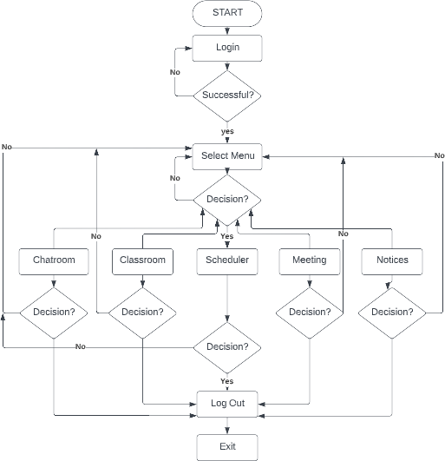

### 3.4 Requirements

### 3.4.1 Hardware Requirements

Pentium IV or higher, (PIV-300GHz recommended)

256 MB RAM

1 GB hard free drive space

#### 3.4.2 Software Requirements

1. **VS CODE**

The Visual Studio Code, also commonly referred to as VS Code, is a source-code editor made by Microsoft for Windows, Linux and macOS. Features include support for debugging, syntax highlighting, intelligent code completion, snippets, code refactoring, and embedded Git.

#### GOOGLE FIREBASE

Firebase is a platform developed by Google for creating mobile and web applications. Firebase provides a ready-made backend system that frontend developers can use to hook their GUI without waiting for the backend to be ready. Firebase Hosting is production-grade web content hosting for developers.

#### 3.4.3 Technology used

Some of the technologies used in this project are:

#### React JS

React is a free and open-source front-end JavaScript library for building user interfaces based on UI components. It is maintained by Meta and a community of individual developers and companies.

#### Node JS

Node.js is an open-source, cross-platform, back-end JavaScript runtime environment that runs.

#### Express JS

Express.js, or simply Express, is a back-end web application framework for Node.js, released as free and open-source software under the MIT License. It is designed for building web applications and APIs. It has been called the de facto standard server framework for Node.js.

### 3.5 Methodology Research:

**Survey** – Team collaboration in organizations is an effort to facilitate better work delivery and employee engagement. Most of organizations has emphasized on its employees collaborating at the work place. However, there are short comings from team collaboration which should be solved to facilitate better team work. Microsoft Teams collaboration facilitates bringing communication tools in one gathering and sharing working space.

### UI-Design:

**Figma** – Figma is a vector graphics editor and prototyping tool which is primarily web-based, with additional offline features enabled by desktop applications for macOS and Windows.

### Front End:

**React JS** – React makes it painless to create interactive UIs. Design simple views for each state in your application, and react will efficiently update and render just the right components when your data changes. Build encapsulated components that manage their own state, then compose them to make complex UIs.

### Database:

**Google Firebase** – Google Firebase is a Google-backed application development software that enables developers to develop iOS, Android and Web apps. Firebase provides tools for tracking analytics, reporting and fixing app crashes, creating marketing and product experiment.

### Back End:

**Express JS** – It allows programmers to use HTML as a template language and provides various components to build a web app by extending HTML syntax. It provides many features to the programmer to write database queries. Programmers can write database queries on Express JS because it is a framework of NodeJS.

**Node JS** – It is an open-source development platform for executing JavaScript code server-side. Node is useful for developing applications that require a persistent connection from the browser to the server and is often used for real-time applications such as chat, news feeds and web push notifications.

### Project Deployed:

**Netlify** – Netlify is a web developer platform that multiplies productivity. By unifying the elements of the modern decoupled web, from local development to advanced edge logic, Netlify enables a 10x faster path to much more performant, secure, and scalable websites and apps. Our bet on the Jamstack is quickly coming true.

### Curriculum Tools:

Curriculum tools are widely used in high school and college of education. Materials are selected and organized to facilitate class activities. Additional tools, such as discussion forums and online quizzes, are integrated to support collaboration and evaluation. A typical commercial curriculum tool includes three integrated parts: instructional tools, administration tools, and student tools. Instructional tools include curriculum design and online quizzes with automated grading. Administration tools include file management authentication, and authorization. Student tool functions include: Browsing class material: readings, assignments, projects, other resources Collaboration and sharing: asynchronous and synchronous bulletin boards and discussion forums. Learning progress scheduling and tracking: assignment reminders and submission, personal calendars, and activity logs. Self-testing and evaluation: tests designed by instructors to evaluate student performance WebCT and Blackboard are the most popular commercial curriculum tools. A review comparing these two tools suggests that Blackboard’s flexible content management and group work support make it more suitable for independent and collaborative learning. WebCT’s tighter structure and fully embedded support tools make it more appropriate for guided, less independent learning. In general, these tools are tailored more to support class activities than independent research or self-study

CHAPTER 4 IMPLEMENTATION

**CHAPTER 4**

**IMPLEMENTATION**

|  |  |  |
| --- | --- | --- |
| **MODULE** | **OBJECTIVE** | **FEATURES** |
| ACTIVITY LOGS | Manage activity logs | * Admin can manage the activity logs * Admin can edit/delete the activity logs * Admin can see the list of all activity logs * Teacher can see his activity logs |
| CLASS | Tracks all the information and details of classes. | * Admin can add new classes * Admin can see the list of classes details * Only admin can edit and update the record of the classes * Admin will be able to delete the records of the classes * All classes’ forms are validated on client side using JavaScript |
| TEACHER | Tracks all the information of the teacher.  Create, Read, Update and Delete (CRUD) operations will be developed for teachers. | * Admin can add new teacher records * Admin can see the list of teacher details * Only admin can edit and update the record of the teacher * Admin will be able to delete the records of the teacher * All teacher forms are validated on client side using JavaScript |
| ASSIGNMENTS | Administrator to manage Assignments | * Admin can manage the assignment * Admin can edit/delete the assignment * Admin can see the list of all assignments * Teacher can see his assignment |
| DEPARTMENTS | Administrator to manage Assignments | * Admin can manage the departments * Admin can edit/delete the departments * Admin can see the list of all departments * Teacher can see his departments |

|  |  |  |
| --- | --- | --- |
| EVENTS | Provides all the functionality related to events and tracks all the information and details of event | * Admin can add new events * Admin can see the list of events details * Only admin can edit and update the record of the events * Admin will be able to delete the records of the events * All events forms are validated on client side using JavaScript |
| SUBJECTS | Administrator can add subjects and a teacher can see subjects | * Admin can manage the subjects * Admin can edit/delete the subjects * Admin can see the list of all subjects |
| STUDENTS | Tracks all the information and details of the students. Create, Read, Update and Delete (CRUD) will be developed for operations of the students. | * Admin can add new students * Admin can see the list of student’s details * Only admin can edit and update the records of the students * Admin will be able to delete the records of the students * All Students publication forms will be validated on the client side using JavaScript. |

**Table 4.1: Proposed Modules**

Based on the modules to be created, TABLE 2 below gives a description of the functional requirements for each user.

|  |  |
| --- | --- |
| **USER** | **FUNCTIONAL REQUIREMENTS** |
| ADMIN | * Login for Admin * Forget password for Admin * Edit Profile for Admin * Change password for Admin * Logout functionality * Dashboard for Admin User * **MANAGE ACTIVITY LOG:** Add New Activity log, edit the existing activity log, view details of the activity log and see a listing of all activity logs. * **MANAGE CLASS:** Add new teacher, edit existing teacher, view details of teacher and see a listing of all teachers. * **MANAGE ASSIGNMENT:** Add new class, edit existing class, view details of a class and see a listing of all classes. * **MANAGE DEPARTMENTS:** Add a new department, edit the existing department, view details of the department and see a listing of all departments * **MANAGE EVENTS:** Add a new event, edit the existing event, view details of events and see a listing of all events * **MANAGE FILES:** Add new files, edit existing files, view details and a listing of all files * **MANAGE STUDENT:** Add new student, edit the existing student, view details of the student and see a listing of all students * **MANAGE SUBJECT:** Add a new subject, edit the existing subject, view details of a subject and see a listing of all subjects. * **REPORTS OF THE E-LEARNING MANAGEMENT SYSTEM:** Reports of Activity logs, Teachers, Classes, Assignments, Departments, Events, Files, Students and Subjects. |
| TEACHER | * **TEACHER REGISTRATION**: Any Teacher can register on the website using the registration module * **TEACHER LOGIN**: This is the login form from where the Teacher can login into the system * **TEACHER ADDS CLASS**: This is the Teacher Add Class form * **TEACHER ASSIGNMENTS ADD:** This is the Teacher assignments |

|  |  |
| --- | --- |
|  | add form of the project   * **TEACHER CLASS**: This is the Teacher class in this project * **TEACHER EVENT**: This is the Teacher Event where a teacher will be able to add an event and see an event report * **TEACHER SEND MESSAGE**: This is the teacher Send Message form where the teacher will be able to send a message * **CHANGE PASSWORD**: This is the change password module from where a teacher can change his account password. * **DOCUMENT UPLOADING**: for teachers: Teachers can also upload documents to aid in teaching |
| STUDENT | * **STUDENT REGISTRATION**: Any Students can register on the website using the registration module * **STUDENT LOGIN**: This is the login form from where students can login to the system * **STUDENT VIEW ANNOUNCMENT SCREEN**: Students can view announcements * **STUDENT ASSIGNMENTS REPORT**: This is the student assignments report of the project * **STUDENT COMPOSE MESSAGE SCREEN**: Student compose message screen * **STUDENT EVENT SCREEN**: A student will be able to see an event report * **STUDENT INBOX SCREEN**: A student will be able to see a message * **CHANGE PASSWORD**: A student can change his account password from this module. |

**Table 4.2: Functional Requirements of user**

|  |  |
| --- | --- |
| **NON – FUNCTIONAL REQUIREMENT** | **OBJECTIVE** |
| Application Security | The system should be protected in such a manner that one registered  user should not be able to access another registered user’s information ensuring privacy of information. |
| Database Security | Users of the system should not have direct access to the database to query it nor view data in it.  The only access to the database should be via the application interface. |
| Browser Compatibility | The application should be accessible on Google Chrome, Mozilla  Firefox & Internet Explorer browsers on any device. |
| Maintainability | The application should be developed so that one can easily add new products and easily facilitate changes to product information. |
| Consistency | The appearance and delivery of the content should be consistent to reduce the learning curve.  Layouts, buttons and the positioning of key elements should be consistent in each page. |
| Usability | How difficult it will be to learn and operate the system. |
| Scalability | Number of users supported will mainly depend on the server load, server processing capacity and its memory. It should scale maximum number of users. |
| Availability | 24 X 7 availability should be there so that student can use it at any time  according to his/her convenience. |

**Table 4.3: Non - Functional Requirements of the system**

CHAPTER 5 RESULTS

**CHAPTER 5**

**5.1 Results**

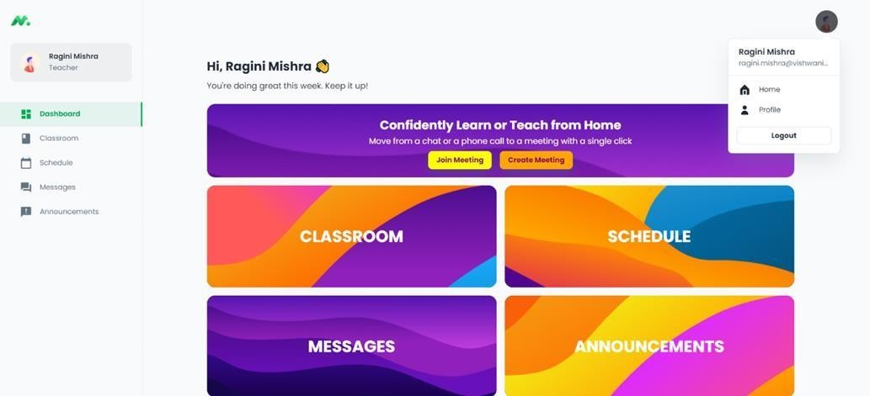

**Fig.No.5.1 Homepage**

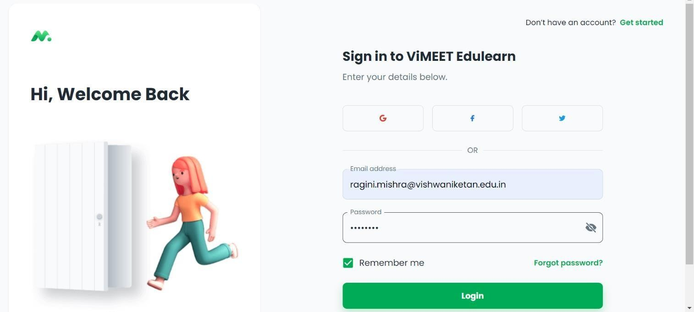

**Fig.No.5.2 Authentication Page**

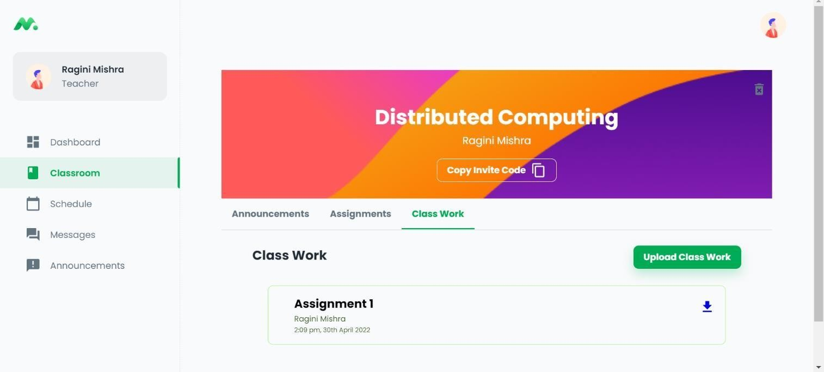

**Fig.No.5.3 Classroom Page**

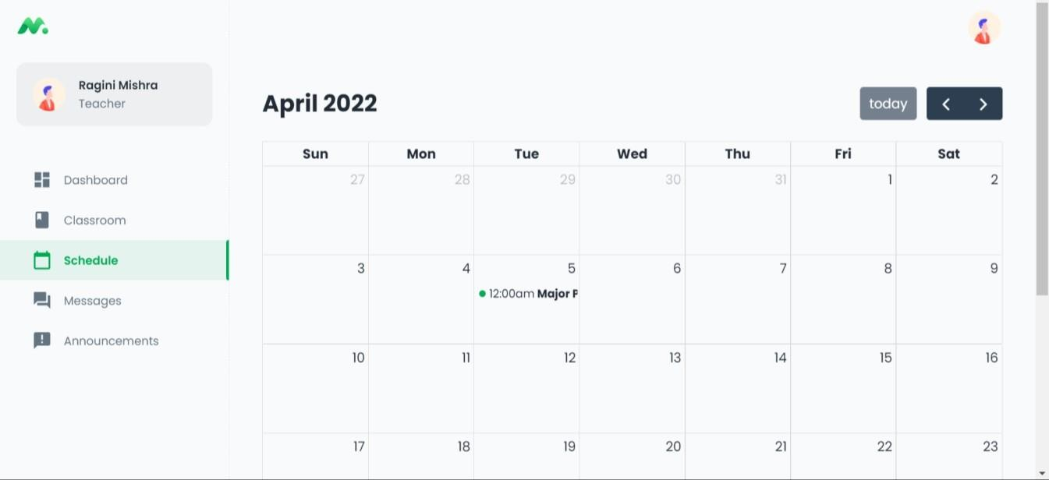

**Fig.No.5.4 Scheduler Page**

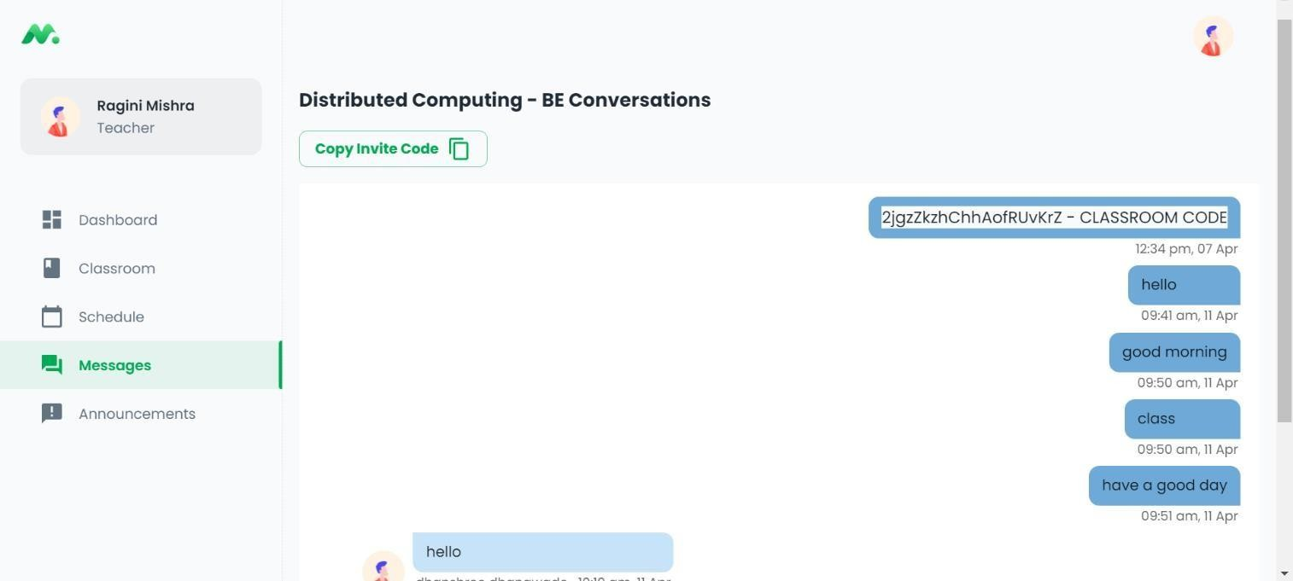

**Fig.No.5.5 Chatroom Page**

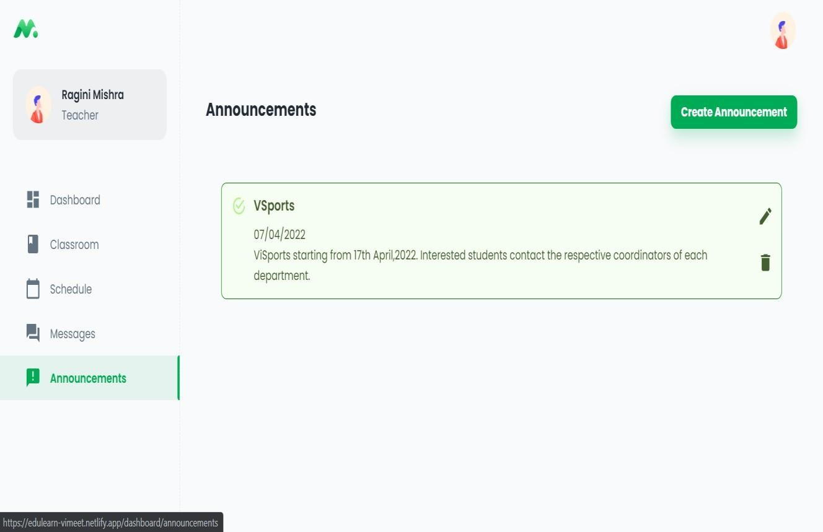

**Fig.No.5.6 Notice Page**

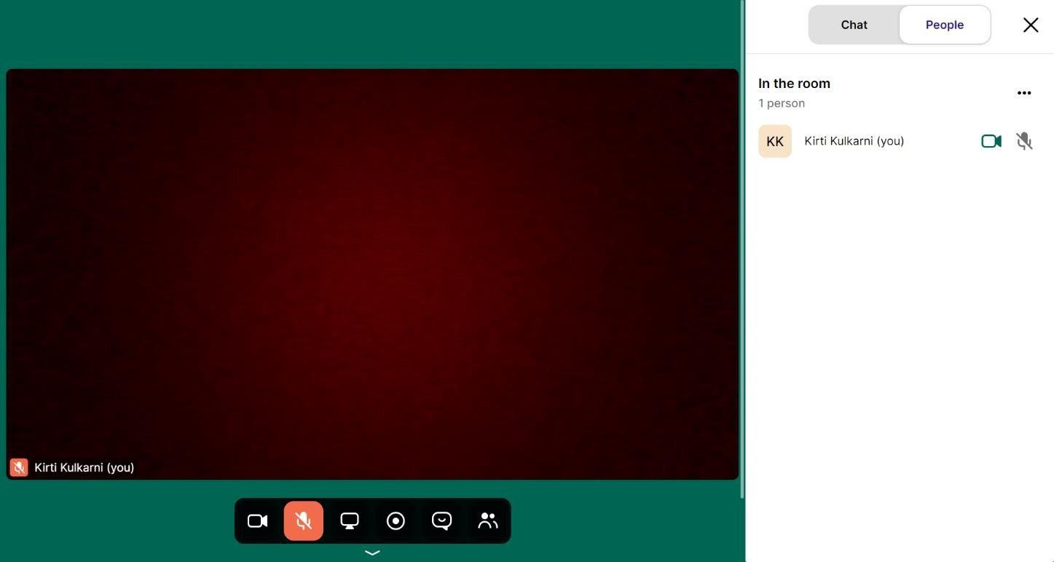

**Fig.No.5.7 Meeting Page**

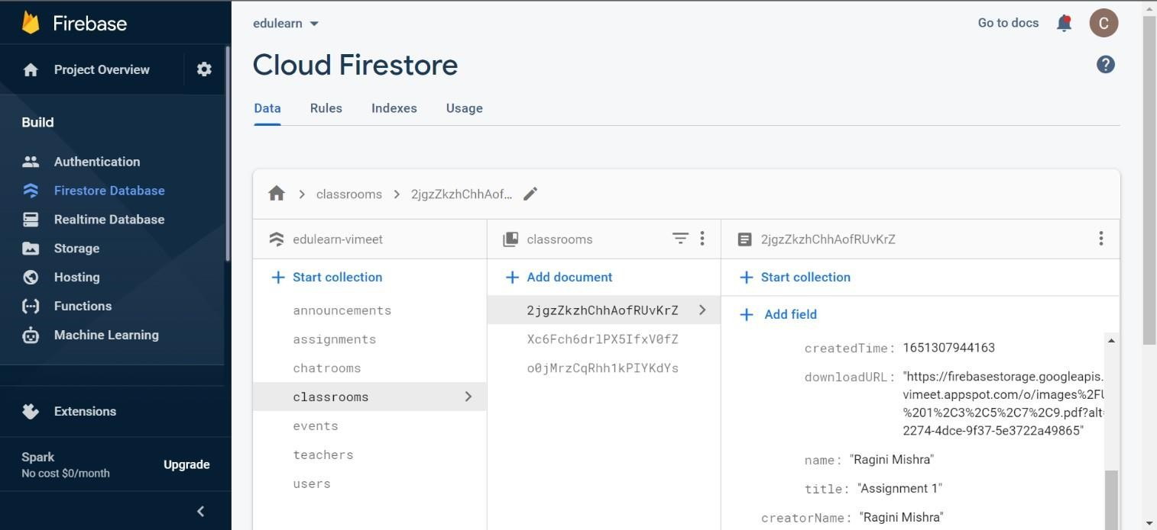

**Fig.No.5.8 Firebase Page**

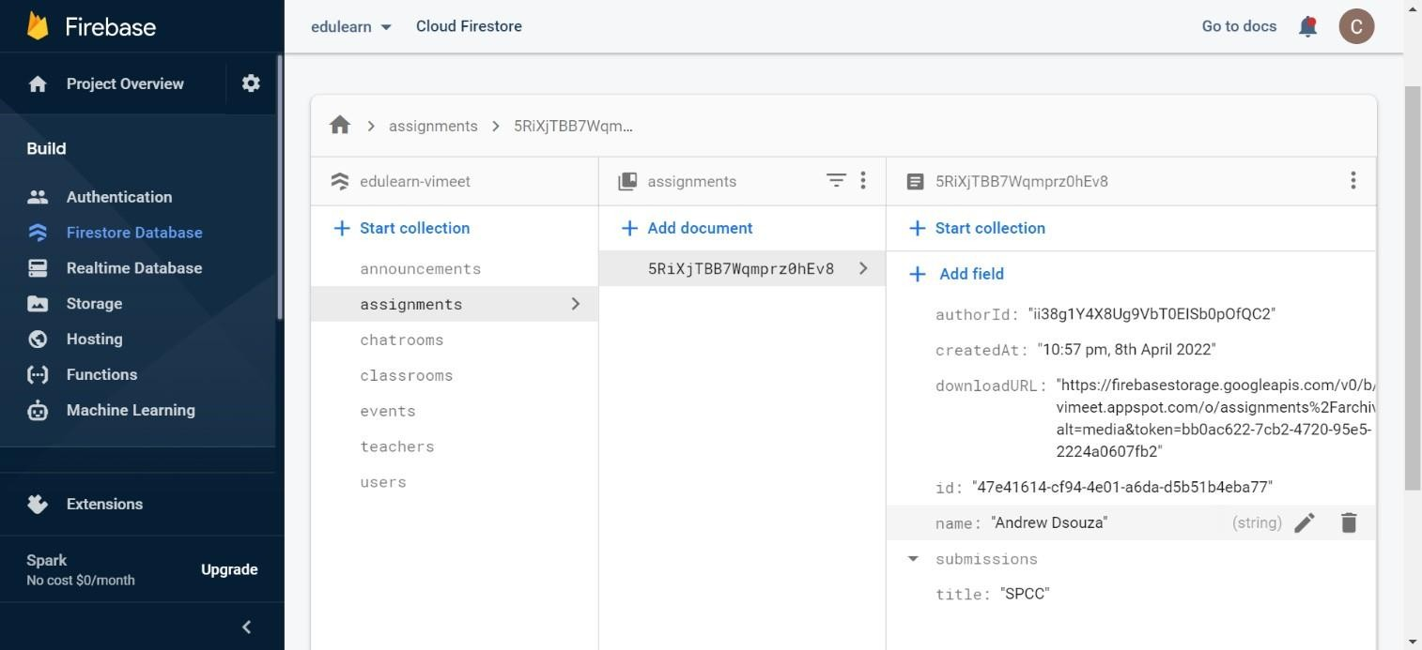

**Fig.No.5.9 Firebase Page**

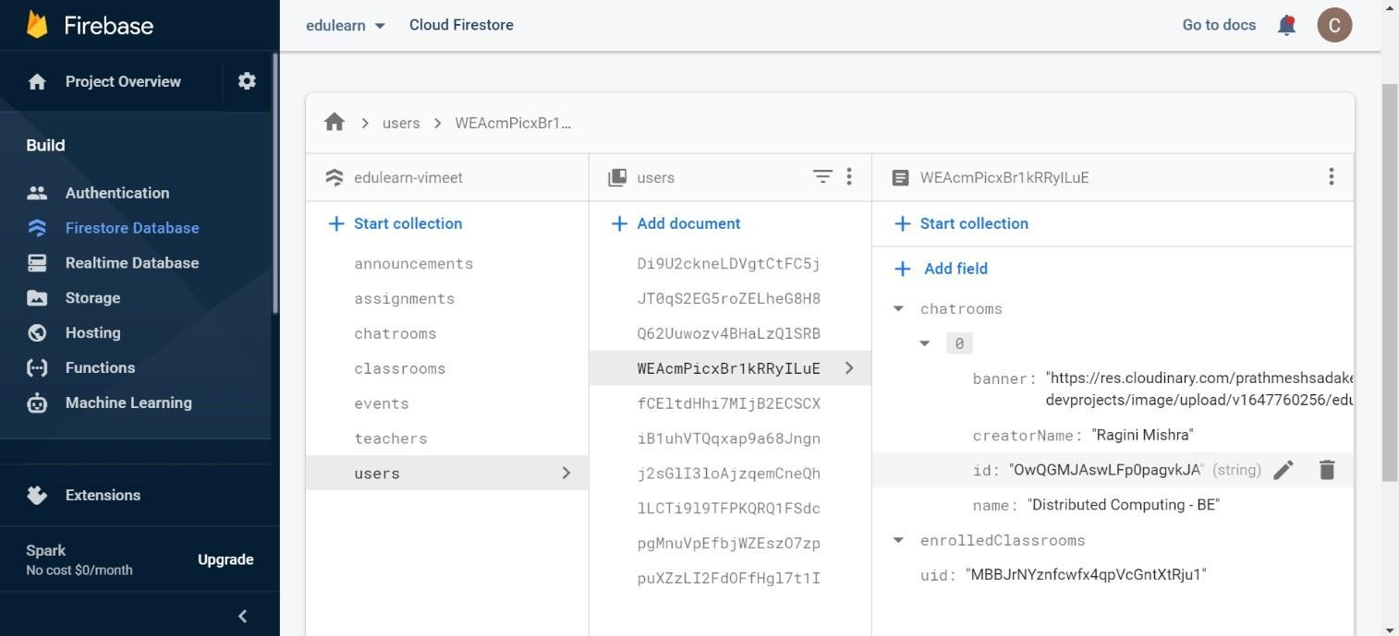

**Fig.No.5.10 Firebase Page**

CHAPTER 6 CONCLUSION

**CHAPTER 6**

**CONCLUSION**

In conclusion, online learning is beneficial to the students, tutors and the institution offering these courses. We would therefore recommend that online learning be implemented on all learning institutions and research on how to improve this learning process should be carried out. Online- learning is not just a change of technology. It is part of a redefinition of how we as a species transmit knowledge, skills, and values to younger generations of workers and students.

Online-learning is not just a change of technology. Learners will have access to millions or billions of knowledge modules. Some will be Web pages with simple text and graphics. Others may include multimedia simulations. In many fields, e-learning has become the default way to conduct training or to provide education. There are four secrets of e-learning. The first secret is to teach what learners need to learn in the way they most naturally learn. The second secret is to define clear learning objectives. The third secret builds on the first two. It is to focus on the right objectives. The final secret is in the power of testing e-Learning.

# CHAPTER 7 FUTURE SCOPE

## CHAPTER 7

### FUTURE SCOPE

* 1. **Future Scope**
     + Automatic Attendance – To keep a track of student’s attendance record easily.
     + Breakout rooms – Making interactive workshops or learning scenarios more productive.
     + Meeting recap – Saves time taking your notes and assigning actions.
     + Fully functional app - Apps are more convenient, faster and efficient.

### REFERENCES

1. https://ieeexplore.ieee.org/document/7395613
2. https://en.wikipedia.org/wiki/Firebase
3. https://expressjs.com/en/5x/api.html
4. https://nodejs.dev/learn/introduction-to-nodejs
5. [https://en.wikipedia.org/wiki/Visual_Studio_Code#:~:text=Visual%20Studio%20Code%2C%20also% 20c](https://en.wikipedia.org/wiki/Visual_Studio_Code#%3A~%3Atext%3DVisual%20Studio%20Code%2C%20also%20c) ommonly,code%20refactoring%2C%20and%20embedded%20Git.
6. https:/[/www.emerald.com/insight/content/doi/10.1108/AAOUJ-09-2020-0078/full/html](http://www.emerald.com/insight/content/doi/10.1108/AAOUJ-09-2020-0078/full/html)
7. https:[//www.ukessays.com/essays/computer-science/e-learning-management-system-analysis-design-](http://www.ukessays.com/essays/computer-science/e-learning-management-system-analysis-design-) implementation-and-evaluation.php
8. https:[//www.academia.edu/35173974/Research_paper_on_E_Learning_Application_Design_Features_](http://www.academia.edu/35173974/Research_paper_on_E_Learning_Application_Design_Features_) using_Cloud_Computing_and_Software_Engineering_Approach
9. https:/[/www.researchgate.net/publication/305686215_Research_paper_on_E-](http://www.researchgate.net/publication/305686215_Research_paper_on_E-) Learning_application_design_features_Using_cloud_computing_software_engineering_approach
10. https:[//www.researchgate.net/publication/338715552_USING_MICROSOFT_TEAMS_TO_SUPPOR](http://www.researchgate.net/publication/338715552_USING_MICROSOFT_TEAMS_TO_SUPPOR) T_COLLABORATIVE_KNOWLEDGE_BUILDING_IN_THE_CONTEXT_OF_SUSTAINABILIT Y_ASSESSMENT
11. https://en.wikipedia.org/wiki/Heroku
12. https://temp-mail.org/en/
13. https:/[/www.netlify.com/](http://www.netlify.com/)
14. https://360degreecloud.com/steps-to-successful-ui-ux-design-implementation/amp/